Department:
SOFTWARE ENGINEERING
Subject:
OOP(java) lab
Date:10/MAy /2025

QUESTION NO 1:

CODE:
import javax.swing.*;
import java.awt.*;
public class Main {
public static void main(String[] args){
JFrame f = new JFrame();
f.setTitle("MyFrame");
f.setSize(400, 200);
f.setDefaultCloseOperation(JFrame.EXIT_ON_CLOSE);
f.setLayout(new GridLayout(3, 2, 10, 10));
JLabel label1 = new JLabel("Enter First Number");
JTextField t1 = new JTextField();
JLabel label2 = new JLabel("Enter Second Number");
JTextField t2 = new JTextField();
JPanel buttonPanel = new JPanel();
buttonPanel.add(new JButton("+"));
buttonPanel.add(new JButton("-"));
buttonPanel.add(new JButton("*"));
buttonPanel.add(new JButton("/"));
f.add(label1);
f.add(t1);
f.add(label2);
f.add(t2);
f.add(buttonPanel);
f.setVisible(true);
}
}

SCREENSHOT:
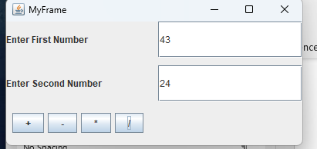

QUESTION NO 2:
CODE:
import javax.swing.*;
import java.awt.*;
public class Main {
public static void main(String[] args) {
JFrame f = new JFrame("tiile form frame");
f.setDefaultCloseOperation(JFrame.EXIT_ON_CLOSE);
f.setSize(400, 200);
f.setLayout(new BorderLayout());
JPanel formPanel = new JPanel(new GridLayout(2, 2, 5, 5));
JLabel firstNameLabel = new JLabel("First Name:");
JTextField firstNameField = new JTextField();
formPanel.add(firstNameLabel);
formPanel.add(firstNameField);
JLabel lastNameLabel = new JLabel("Last Name:");
JTextField lastNameField = new JTextField();
formPanel.add(lastNameLabel);
formPanel.add(lastNameField);
JPanel buttonPanel = new JPanel(new FlowLayout(FlowLayout.CENTER, 10, 10));
JButton submitButton = new JButton("SUBMIT");
JButton clearButton = new JButton("CLEAR");
buttonPanel.add(submitButton);
buttonPanel.add(clearButton);
JButton exitButton = new JButton("EXIT");
JButton helpButton = new JButton("HELP");
buttonPanel.add(exitButton);
buttonPanel.add(helpButton);
f.add(formPanel, BorderLayout.NORTH);
f.add(buttonPanel, BorderLayout.CENTER);
f.setVisible(true);
}
}

SCREENSHOT:

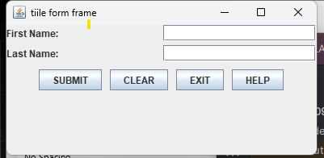
QUESTION NO 03:
CODE:
import javax.swing.*;
import java.awt.*;
public class Main{
public static void main(String[] args) {
// Create the main frame
JFrame fra = new JFrame("Simple Form");
fra.setDefaultCloseOperation(JFrame.EXIT_ON_CLOSE);
fra.setSize(400, 200);
fra.setLayout(new BorderLayout());
JPanel formPanel = new JPanel(new GridLayout(2, 2, 5, 5));
JLabel firstNameLabel = new JLabel("First Name:");
JTextField firstNameField = new JTextField();
formPanel.add(firstNameLabel);
formPanel.add(firstNameField);
JLabel lastNameLabel = new JLabel("Last Name:");
JTextField lastNameField = new JTextField();
formPanel.add(lastNameLabel);
formPanel.add(lastNameField);
JPanel buttonPanel = new JPanel(new FlowLayout(FlowLayout.CENTER, 10, 10));
JButton submitButton = new JButton("Submit");
JButton clearButton = new JButton("Clear");
buttonPanel.add(submitButton);
buttonPanel.add(clearButton);
JButton resetButton = new JButton("Reset");
JButton exitButton = new JButton("Exit");
JButton helpButton = new JButton("Help");
buttonPanel.add(resetButton);
buttonPanel.add(exitButton);
buttonPanel.add(helpButton);
fra.add(formPanel, BorderLayout.NORTH);
fra.add(buttonPanel, BorderLayout.CENTER);
fra.setVisible(true);
}
}

SCREENSHOT:

